GETTING STARTED WITH TAPESTRY
Activating your account from an activation email
You will be sent an email activation by Stepping Stones Pre-school, you can just use that link to log in for the first time. Please note that this email is sent from noreply@tapestryjournal.com, so it might end up on your spam/junk folder! If we tell you that we've sent you an activation email but this is nowhere to be seen, please do check your clutter box and make sure to mark noreply@tapestryjournal.com as a trusted sender.
The email will look like this on your inbox:
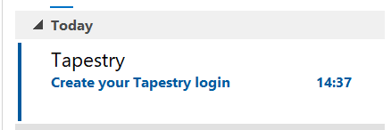
You will have to click on the email to access the activation link, which reads 'Create your password':
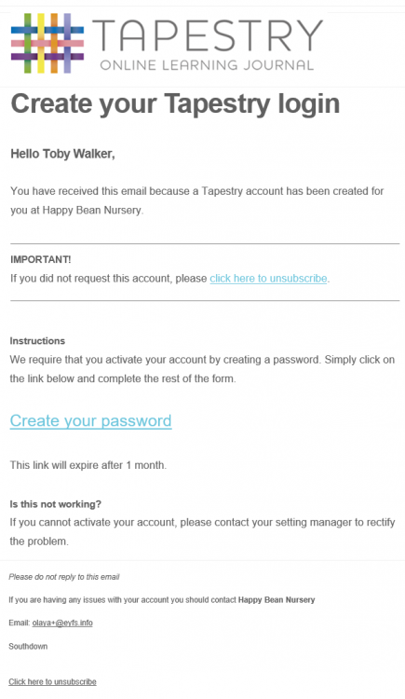
The link will take you to the following screen:

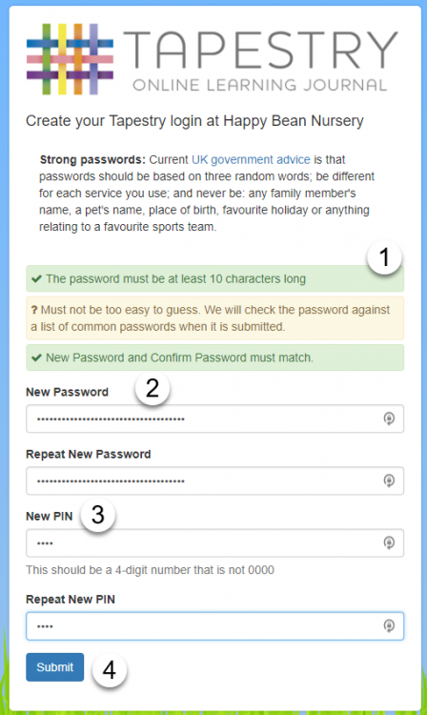
(1) determines the minimum specifications that you will need to meet for your password to be accepted. These are set up by the school and have been thought to ensure that your password is secure due to the sensitive nature of the data you can access from your Tapestry account.
(2) here you will have to type in your password of choice (the requirements will highlight in red as you meet them), and then repeat it just underneath.
(3) here you can register a PIN number of choice. If you leave the Tapestry app or your tablet goes into sleep mode you will be taken to the PIN screen next time you try to use the Tapestry app. This is so that you can be sure no one will be able to just pick up your device and get into Tapestry, but it also allows you to access your account without having to type in your full set of login details again. If you're not sure what your PIN is, you can press the red 'logout' button and then you should be able to login normally using your username and password.
(4) press 'submit' to register your log in details.
You will now be able to access your account by logging in with your email address and password:
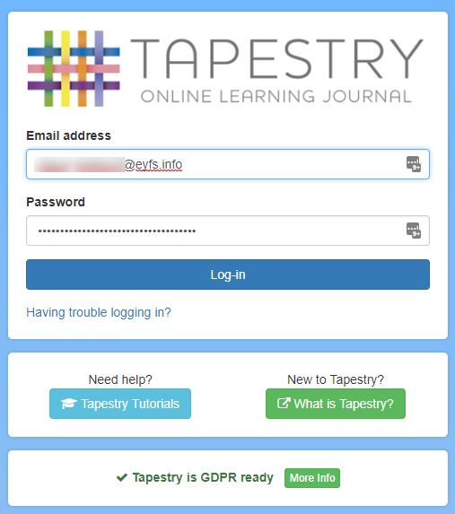
You will also receive an email confirming that your account has been activated:
Once you have successfully logged in, you will be taken to the home page. Here you can change the password to something of your choice by clicking on your profile's drop-down menu and then selecting 'Edit Preferences'. From here, navigate to 'Change Password'.
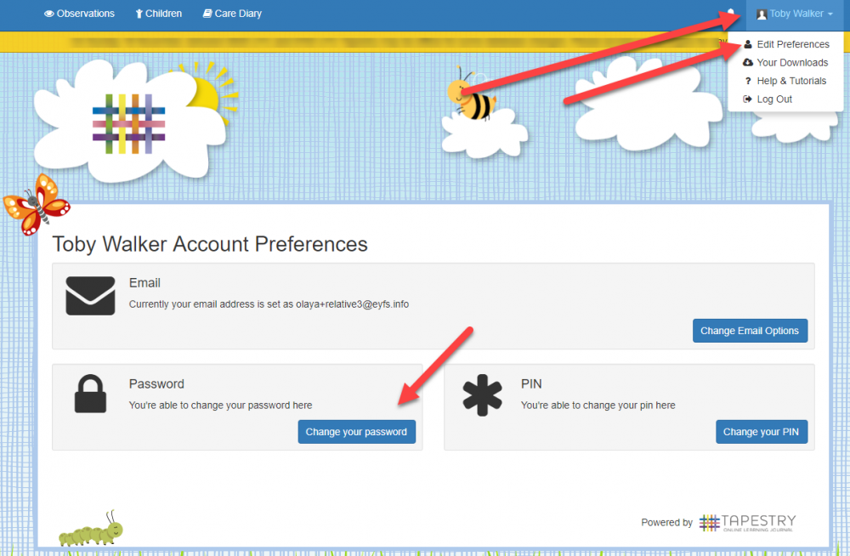
Navigating through your account
Once logged in you will be taken to the main page, where you will be able to see your child's observations in chronological order. It is likely that the first time you log in there won't be very many, but this list will grow throughout your child's time at the setting.
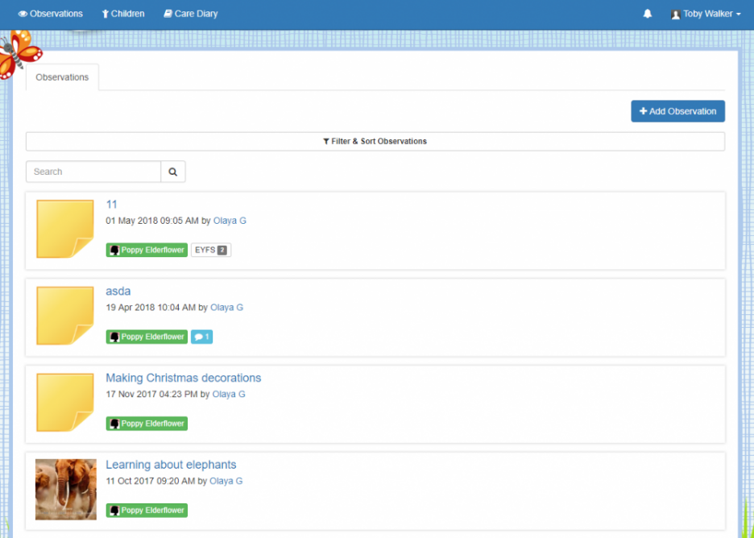
At the top of the screen, next to your name, you will find your notification bell. If any observations/comments have been added since the last time you logged into Tapestry, they will show up there. You can see past notifications by clicking on 'View All Notifications'.
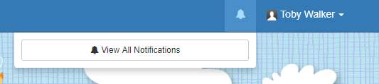

There will be times when you want to add observations to Tapestry. These can then be seen by your child's key person at their Setting and used to make assessments, or just as a contribution to the journal.
In order to add an observation, you first need to click on the blue 'Add Observation' button. This can be found on the home 'Observations' tab.
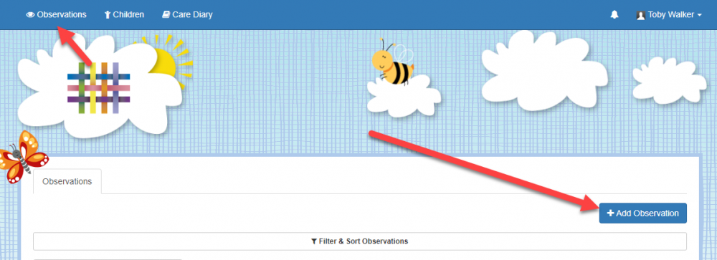
Once you have clicked on it, you will be taken to the page shown below. Here you will need to pick your child/children from the drop down list, add a title, and then you can add some notes and media.
Don't forget to press 'Save' at the end!
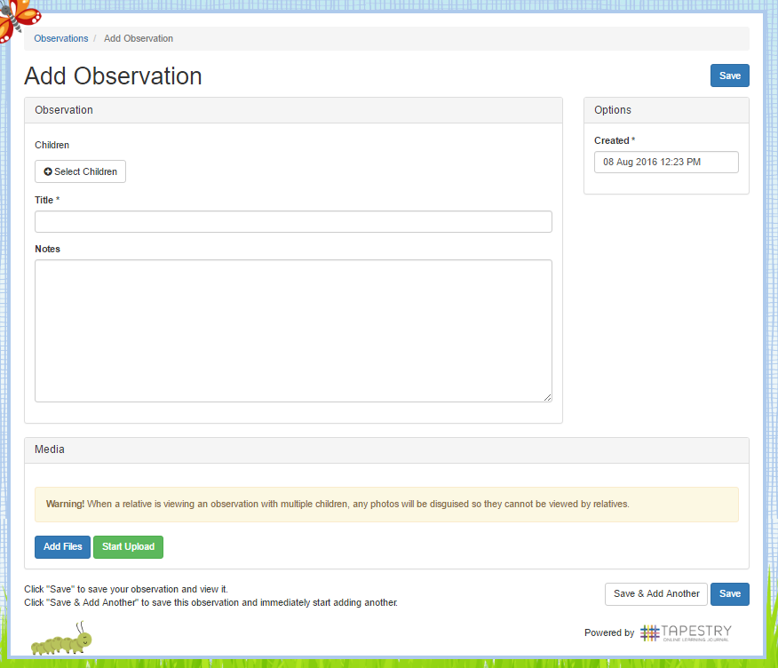
There are a couple of other things you can do on Tapestry. The most obvious, is to look at the 'Children' tab. Here you will be able to find all the children that are linked to you from a particular Setting.
The other area on relative accounts is 'Edit Preferences, we have already touched this at the beginning of the tutorial. You can find this by clicking on your name in the top right hand corner and choosing it from the drop down list. This drop down list is also where you log off from (though it will log you off automatically if you close the page or are inactive for an hour or more).
Clicking on 'Edit Preferences' will take you to this page. As you can see, it will show you which children you are connected to you, your notification preferences (if this has been enabled for you), and give you the option to change your email and password.
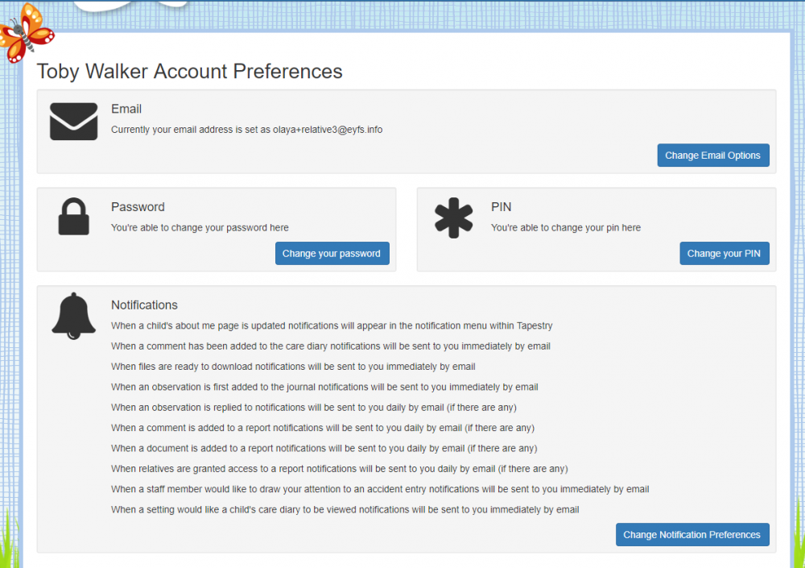
And that's everything! Hope you enjoy Tapestry, any problems please ask a member of the team.

